Doctoral Occupational Therapy Capstone Report

Madeline Bloemer
Department of Occupational Therapy, Xavier University
OCTD 802: Capstone Scholarship
Dr. Leah Dunn
November 25, 2025

Table of Contents
Introduction to the Doctoral Capstone 5
Doctoral Capstone Title 5
Purpose of the Capstone Project 5
Theoretical Models 5
Content Area 5
Scholarship Type 5
Capstone Relationship to Mission and Philosophy 6
Xavier University Mission 6
Department of Occupational Therapy Mission 6
Department of Occupational Therapy Philosophy 6
Relationship 6
Capstone Development Part I 7
Capstone Site 7
Literature Review and Needs Assessment 7
Literature Review 7
Needs Assessment 7
Capstone Development Part II 8
Capstone Proposal 8
Capstone Goals and Objectives 8
Capstone Project Plan 8
Capstone Evaluation 8
Capstone Memorandum of Understanding 9
Capstone Implementation and Results 10
Activity 1 10
Description of the Participants 10
Implementation/Methodology 10
Results 10
Activity 2 10
Description of the Participants 10
Implementation/Methodology 10
Results 10
Activity 3 10
Description of the Participants 11
Implementation/Methodology 11
Results 11
Capstone Discussion 12
Evaluation of the Captone Project (Activity 1) and Correlation with Literature 12
Recommendations for Practice, Policy, and/or Education 12
Evaluation of the Captone Project (Activity 2) and Correlation with Literature 12
Recommendations for Practice, Policy, and/or Education 12
Evaluation of the Captone Project (Activity 3) and Correlation with Literature 12
Recommendations for Practice, Policy, and/or Education 12
Reflection of the Capstone 12
Reflective Synthesis/ Creative Epilogue 13
Appendix A: Literature Table 14
Appendix B: Scoping Review 15
Appendix C: IRB Application 16
Appendix E: Capstone Goals and Objectives for a Capstone Project Table and a Capstone Experience Table 17
Appendix F: Signed Memorandum of Understanding 18
Appendix G: IRB Letter of Response 19
Appendix H: Week-by-Week Project Plan 20

INSERT STATEMENT HERE

Madeline Bloemer 11/25/2025
_____________________________________________ _____________________
Student Date
Marnie Renda 11/25/2025
____________________________________________ ___________________
Capstone Coordinator Date
Leah Dunn 11/25/2025
_____________________________________________ ___________________
Faculty Mentor Date
Angie Watson 11/25/2025
___________________________________________ ___________________
Capstone Site Date

Introduction to the Doctoral Capstone
The doctoral capstone is a culminating project and experience for doctoral capstone students that occurs after all clinical and didactic courses are completed. The evidence-based project requires the student to relate theory to practice, synthesizing in-depth knowledge in a specific practice area. The experience provides an in-depth exposure to a concentration area. Throughout the project and experience, the student is mentored by the capstone site (recipient), the Xavier University Faculty Mentor, and the Doctoral Capstone Coordinator.

This capstone proposal section contains the capstone title, purpose, theoretical models used, content area, type of scholarship, and the relationship to the Xavier University Mission and the Department of Occupational Therapy Mission and Philosophy.

Doctoral Capstone Title
Shared Spaces, Shared Understanding: An Evaluation of a Mentoring Program to Strengthen Relational Quality between Neurodivergent and Neurotypical Peers

Purpose of the Capstone Project
The purpose of this capstone was to promote inclusion between neurotypical and neurodivergent collegiate-age peers. It was also completed to increase comfort and confidence levels in neurotypical Xavier University students while interacting with neurodivergent peers.

Theoretical Models
Below is a brief description of the conceptual or theoretical model(s) used to frame this capstone project and how it was applied.
Several theoretical models informed the design and implementation of this capstone project. The primary framework utilized was the Developmental Frame of Reference. Because one of my main goals was to support students in developing new skills, each lesson was intentionally structured to build upon the previous week’s content. For example, when teaching emotional regulation, concepts were gradually layered to promote skill acquisition over time. This model directly aligned with my project goals and was manageable to apply given the small group size of eight interns.
The second theoretical model guiding this project was the Teaching–Learning Theory. Throughout the experience, I frequently assumed the role of educator—whether teaching emotional regulation strategies, providing guidance to families on next steps, or supporting Xavier students as they navigated new interpersonal experiences. This framework offered valuable direction for effective teaching techniques and informed the development of engaging, accessible lessons.
Finally, the Occupational Adaptation Model shaped my understanding of how both Project SEARCH interns and ESA members could grow through shared experiences. This model emphasizes the dynamic process of individuals adapting to their environment. A central aim of the project was for both groups to learn from one another within a shared context, and this goal was successfully achieved. Although I initially considered the possibility of negative peer influence, the interactions ultimately resulted in positive, mutually beneficial adaptation.

Content Area
The goal of the doctoral capstone is to provide students with an in-depth exposure to one or more of the content areas. These include: clinical skills, research skills, program development and assessment, policy development, advocacy, education, and leadership. Students select a primary and secondary content area.
The primary content area of this capstone project was program development and assessment. A key objective involved evaluating the experiences of Xavier student mentors and implementing improvements to strengthen the program. All materials and resources developed throughout the semester were compiled into a reusable folder and provided to my capstone site mentor to support ongoing use in future years.
The secondary content area was advocacy. This stemmed from my efforts to promote inclusion of neurodivergent participants in everyday community activities. The outcomes of this project provide clear evidence of the benefits of such inclusion and highlight the essential role of advocacy—particularly when supporting individuals who may not have the ability to advocate for themselves.

Scholarship Type
Student capstone projects are considered scholarly studies. The project represents one of the four types of scholarship: (1) scholarship of discovery, (2) scholarship of application, (3) scholarship of teaching and learning.

The primary form of scholarship demonstrated in this capstone is the Scholarship of Teaching and Learning. Throughout the experience, I consistently engaged in both teaching and learning—sharing my knowledge of occupational therapy and inclusive practices while simultaneously gaining valuable insights from the interns and Xavier students. The teaching component was particularly significant, as many of the individuals I worked with had significant intellectual and developmental disabilities. This required me to carefully adapt my instructional methods to meet their unique learning needs and levels of understanding. Developing this skill has been essential to my growth and will remain critically important in my future career as an occupational therapist.

Capstone Relationship to Mission and Philosophy
The doctoral capstone is related to the Xavier University Mission and the Department of Occupational Therapy Mission and Philosophy.

Xavier University Mission
Xavier is a Jesuit Catholic university rooted in the liberal arts tradition. Our mission is to educate each student intellectually, morally and spiritually. We create learning opportunities through rigorous academic and professional programs integrated with co-curricular engagement. In an inclusive environment of open and free inquiry, we prepare students for a world that is increasingly diverse, complex and interdependent. Driven by our commitment to educating the whole person, promoting the common good, and serving others, the Xavier community challenges and supports all our members as we cultivate lives of reflection, compassion and informed action.

Department of Occupational Therapy Mission
Our Mission is to educate and prepare future occupational therapists who respond to the occupational needs of a diverse, complex, interdependent, and ever-changing global society. Xavier University OTD graduates will practice as ethical, competent, and caring professionals using critical, creative, and reflective thinking and habits of lifelong learning. As professionals, Xavier University graduates will balance autonomous and collaborative decision-making to successfully navigate a variety of inclusive delivery systems in traditional and emerging practice areas where they implement theory-driven and evidence-based practice. Xavier University graduates will be leaders who model and advocate for justice for persons, groups, and populations. To promote occupational participation and advance the profession, our graduates will utilize, produce, and disseminate scholarly works.

Department of Occupational Therapy Philosophy
We believe:
- Humans are biopsychosocial beings who are transformed by participation in occupation.
- Participation in meaningful occupations shapes human lives and is intrinsically connected to one’s health and well-being.
- As members of intra- and inter-professional teams, occupational therapists form a dynamic and collaborative relationship with people, populations, and communities to maximize occupational participation and realize occupational potential.
- Best practice in occupational therapy is client-centered, occupation-based, theory-driven, evidence-based, and grounded in sound ethical principles.
- Students learn best through independent exploration coupled with active engagement in authentic and learner-centered learning experiences and self-reflection.

Relationship
Below is a description of the relationship between the doctoral capstone and the mission of the Xavier University and the mission and philosophy of the Department of Occupational Therapy meeting ACOTE standard D.1.3).

The Xavier University mission statement affirms that ‘in an inclusive environment of open and free inquiry, we prepare students for a world that is increasingly diverse, complex, and interdependent.’ By promoting inclusion and fostering readiness for everyday life, my capstone project directly supports this mission. It contributes to the ways in which the Xavier community prepares students of all ability levels for real-world experiences and ensures equitable opportunities for community engagement. The outcomes of this project also highlight the significance of the term ‘interdependent,’ demonstrating how mutually beneficial the interactions were between the two participating groups.

Capstone Development Part I

Part I of the capstone development includes a literature review, site interview, and needs assessment. These form the foundation of the capstone project described in the following section of this proposal. This section provides documented evidence of ACOTE standard D.1.3 which states that “the doctoral capstone is an integral part of the program’s curriculum design’ and reflects the mission and philosophy of the program, contributes to the development of in-depth knowledge in a designated area of interest, and includes preparation consisting of a literature review and needs assessment” (ACOTE, 2023)

Capstone Site
The capstone site is the organization in which the student partners to complete the project and experience. The site is selected in collaboration with the student, doctoral capstone coordinator, and the faculty mentor.

For this capstone, I partnered with Project SEARCH on Xavier University’s campus. Project SEARCH is a program that provides individuals with intellectual and developmental disabilities aged 18-22 with internships on Xavier’s campus in hopes of them obtaining competitive employment at the conclusion of the program. The mission statement of Project SEARCH is “Project SEARCH provides an opportunity and an atmosphere of high expectations. People with disabilities have the right to choose a path toward education and employment. We strongly believe and expect that each intern can achieve the goal of competitive employment.” I fully agree with this statement which is one of the many reasons this site was a perfect fit for me.

Literature Review and Needs Assessment

Literature Review
The doctoral capstone literature review was conducted in OCTD 604 (See Appendix A: Literature Table), OCTD 633 (See Appendix B: Scoping Review), and OCTD 705 (See Appendix C: IRB Application Problem Statement).

Needs Assessment
Needs Assessment for the doctoral capstone was completed in OCTD 604 in collaboration with the student, faculty mentor, and doctoral capstone coordinator and was used as the foundation for this doctoral capstone. The Needs Assessment contains parts: (1) review of the literature, (2) description of the problem, and (3) site interview. See Appendix D: Needs Assessment.

Capstone Development Part II

The section contains the doctoral capstone proposal, which includes the goals and objectives, week-by-week project plan, and capstone evaluation plan. This section contains evidence that the doctoral capstone was “designed through collaboration with the student, a faculty member in the occupational therapy educational program who holds a doctoral degree, and an individual with documented expertise in the content area of the capstone” (ACOTE D.1.1, 2023), contains “goals/objectives, and a plan to evaluate project outcomes” (ACOTE, D.1.3), and that the site mentor (content expert) was “informed of the plan for and purpose of the doctoral capstone” (ACOTE D.1.2).

Capstone Proposal

Capstone Goals and Objectives
Goals and objectives are defined for both the capstone (1) project and (2) experience. The goals describe what students will learn or do, while the objectives define how this will be accomplished. Each goal and objective is listed with the proposed evidence of achievement for each. There is one table for the capstone project goals and objectives, and a separate table for the capstone experience. See Appendix E: Capstone Goals and Objectives for a Capstone Project Table and a Capstone Experience Table.

The doctoral capstone experience learning goals and objectives, as well as the project goals and objectives, were collaboratively developed by the student, faculty mentor, and doctoral capstone coordinator. All goals and objectives were reviewed with the site mentor. Evidence of this is provided in the site mentor-signed Memorandum of Understanding which contains the individual student goals and objectives. See Appendix F: Signed Memorandum of Understanding.

Capstone Project Plan
The capstone project plan consists of a Week-by-Week Project Plan and the procedures section of the IRB Application. Each was collaboratively developed by the student, faculty mentor, and doctoral capstone coordinator. See Appendix C: IRB application and Appendix G: IRB Letter for the Response to the IRB Application. See Appendix H: Week-by-Week Table for the planned capstone activities by week.

Capstone Evaluation
The capstone evaluation is determined by assessing the student’s ability to meet their capstone goals and objectives. The capstone evaluation is divided into two sections: (1) project and (2) experience and is completed at mid-term (approximately week 7) and again at week 14 (final). The mid-term and final capstone evaluations are completed and maintained on EXXAT/Prism.

Capstone Memorandum of Understanding
A capstone Memorandum of Understanding (MOU) is executed prior to the start of the doctoral capstone and contains the roles and responsibilities of all parties, plans for evaluation, mentoring and supervision (ACOTE, 2023, D.1.4). See Appendix F: Signed Memorandum of Understanding.

Capstone Abstract
At the outset of this capstone experience, my primary objective was to help bridge the social gap between neurodiverse and neurotypical college-aged peers. After students with intellectual and developmental disabilities (IDD) transition out of structured K–12 educational environments, they often lose natural opportunities for social integration. Although the prevalence of IDD continues to rise, meaningful interactions between individuals with and without IDD remain limited due to factors such as insufficient exposure, general apprehension, and a lack of education regarding appropriate social engagement (Hornby & Kauffman, 2024).Throughout this semester, I contributed to increasing socialization, developing social skills, and enhancing comfort levels not only for the IDD students I worked with but also for the neurotypical Xavier University students involved in the program. In addition to accomplishing my initial goal, I supported several other program needs. These responsibilities included teaching emotional regulation strategies to IDD students, providing instruction on appropriate interactions across differing ability levels, serving on grant review boards, exploring assistive technology solutions for workplace support, and more. Overall, this experience was both successful and deeply rewarding. I am grateful for the opportunity to complete my capstone project with Project SEARCH.

Capstone Implementation and Results
Activity 1
To evaluate improvements in comfort level and confidence within the Exceptional Student Assembly (ESA), I conducted semi-structured interviews with members of ESA. These individuals regularly engage with Project SEARCH (PS) interns through weekly lunches and monthly collaborative events involving both organizations. The interviews, conducted via Microsoft Teams, explored participants’ experiences within ESA, changes in their confidence when interacting with individuals with disabilities, and the key factors they identified as most beneficial or challenging when engaging with peers of differing ability levels. The findings from this study were utilized to strengthen and enhance the partnership between PS and ESA in future initiatives. This part of the capstone required approval from the Institutional Review Board (IRB) which took an extended period of time and many modifications to the protocol to ensure participant protection. Perfecting the IRB protocol took the majority of the semester and played a significant role in this activity.
First, ESA mentors expressed a desire for additional background training on disabilities. They felt that their current understanding was limited to surface-level information on disabilities. They believed that having more comprehensive knowledge—particularly regarding how certain disabilities may affect individuals—would allow them to engage with PS mentees in a more confident and relaxed manner.
Second, mentors voiced interest in having more spontaneous opportunities to interact with their mentees. At present, the two groups share only a few structured interactions throughout the semester. While these experiences are valued and appreciated, mentors felt that increased frequency and variety of interactions could help strengthen their relationships.
Third, mentors indicated that support with conversation starters would be beneficial. Because individuals with intellectual disabilities may experience challenges with social communication, mentors felt that having guidance on appropriate topics to initiate—and avoid—would help conversations flow more smoothly and prevent either party from feeling burdened by maintaining the dialogue.
Fourth, mentors suggested that it would be helpful for interns to provide short personal biographies before meeting with their mentors. This would give mentors an opportunity to learn relevant background information in advance, reducing the likelihood of unintentionally mentioning potential triggers or sensitive topics, especially since individuals with disabilities may not always feel comfortable articulating their needs in the moment.
Finally, ESA members expressed an overall sense of satisfaction and gratitude for their relationship with PS. Hearing this feedback was encouraging and reaffirmed to both my site mentor and myself that our efforts were having a positive impact.

Description of the Participants
Participants in this study were 8 members of the ESA, a student organization at Xavier University composed of neurotypical college students who volunteer as mentors for PS interns. The ESA participants selected for this study were those actively involved in weekly lunch meetings with PS interns.

Implementation/Methodology
For participant recruitment, I approached ESA members during their weekly lunch meetings to introduce the project and explain its objectives and procedures. 11 Individuals were invited to participate, and 8 of them agreed. A hard copy of the informed consent form was provided, allowing participants to review and sign if they chose to participate. Upon receiving consent, an interview date was scheduled. All interviews[DL1] were conducted and recorded via Microsoft Teams to allow for transcription and video review to ensure accuracy. The purpose of the interviews was to evaluate the ESA members’ comfort level and confidence as it relates to interacting with their peers who have a disability. Following the completion of the interviews, the data collection protocol outlined in my IRB submission was strictly followed. The collected data were analyzed, and the findings informed the development of a toolkit designed to support future ESA members and PS interns, with the goal of further strengthening their collaborative relationship.

Modifications
The most significant modification to this activity resulted from delays in the Institutional Review Board (IRB) approval process. Originally, the project design included both pre- and post-interviews to track participant progress[DL1] over time. The original outline also included PS mentees. However, due to time constraints, the methodology was adjusted to include only post-interviews. Additional revisions to the IRB application were also required to secure final approval.

Results
I received both positive feedback and constructive insights that informed the development of my toolkit. In addition to collecting valuable data, I was able to build meaningful relationships with ESA members and establish myself as a trusted and approachable resource. Through this process, I also became a liaison between the two groups, gaining interpersonal and leadership skills that will be beneficial in my future career. The results of the interviews highlighted ongoing gaps in interactions between peers of differing abilities, providing me with a clearer understanding of how these gaps might be addressed moving forward.

Five main themes were gathered through the interviews. These themes were translated into a file to assist in program development and improvement. The folder was given to my capstone mentor and head of PS to be used in future years, along with suggestions and templates for ease of use. Themes can be seen in the following figure.

Figure 1

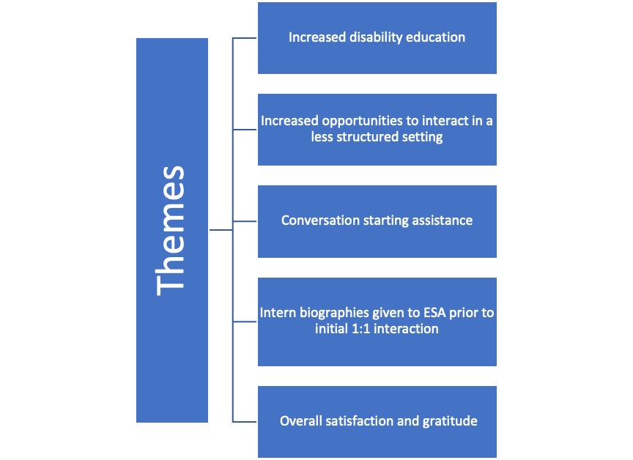

Activity 2
At the beginning of the semester, all 12 of the Project SEARCH (PS) interns experienced challenges with emotional regulation and responding appropriately to difficult situations. Utilizing an occupational therapy (OT) perspective, I assessed their needs and implemented strategies tailored to their individual experiences. Each week, I developed and delivered brief lessons on emotional regulation before the interns began their workday. These sessions covered topics such as understanding emotional regulation, recognizing physiological responses to emotions, and applying effective strategies for managing emotions in the workplace. (Appendix I: Emotional Regulation Lesson Example).

Description of the Participants
The participants in this activity were the Project SEARCH (PS) interns with whom I had the privilege of working throughout the semester. Project SEARCH is a program designed to help young adults with developmental disabilities acquire essential work and life skills through internship experiences at various community workplaces, with the goal of achieving competitive employment upon program completion. The information presented during these sessions proved beneficial not only for the interns but also for the PS staff, who frequently attended the lessons and later shared how they applied the techniques in their own daily routines.

Implementation/Methodology
This component was not part of my original capstone plan; however, as I spent more time with the interns throughout the semester, I observed a notable need in this area. In response, I developed and adapted lessons and activities to address their specific needs and the behaviors I had observed over time. My capstone instructor also recognized this deficit and agreed that this addition was an appropriate and valuable enhancement to the project.

Modifications
No modifications were made to this plan aside from its addition to the original capstone scope. It was developed organically in response to the identified needs of the population I was serving.

Results
Based on feedback from the interns’ supervisors, my site mentor, and skills trainers, as well as my own observations in the workplace, it is evident that the emotional regulation strategies have had a positive impact on the interns. They have demonstrated improved self-awareness and communication by expressing their needs more effectively, requesting breaks when feeling overwhelmed, and successfully de-escalating challenging situations that arise during the workday. Additionally, the interns have shown increased insight by recognizing instances of poor emotional regulation in others and articulating how they might respond differently in similar circumstances.

Activity 3

During my capstone experience with Project SEARCH (PS), I was introduced to a new framework called Charting the Life Course (CTLC). CTLC is a conceptual approach designed to encourage young adults to reflect on their personal goals and aspirations, helping them consider what they do and do not want to pursue in life. Often, young adults are strongly influenced by the expectations of friends and family, which can overshadow their own preferences and ambitions. While CTLC was initially intended to provide guidance solely to the interns, we determined that the information would also benefit their parents and members of the Exceptional Student Assembly (ESA).
To share this information, I hosted a parent information session during the PS open house and presented the material through interactive activities at the November ESA event. Including parents offered an important opportunity to reinforce the framework as their young adults progressed through PS, while engaging ESA members helped strengthen the connection between the two groups, both of whom are invested in achieving competitive employment.

Description of the Participants
Participants included Project SEARCH (PS) interns, Exceptional Student Assembly (ESA) members, and parents of PS interns, roughly 45 people total. While the content was adapted to meet the specific needs and perspectives of each group, the overarching message remained consistent across all presentations.

Implementation/Methodology

To effectively communicate the information to each group, the presentations[DL1] were tailored to meet their specific needs. For the parent group, the content was presented using more sophisticated language and framed from a parental perspective, emphasizing how to allow their children the autonomy to make their own choices. This material was organized into a PowerPoint presentation and delivered during a parent meeting.
For the ESA members and PS mentees, the content was appropriately delivered without jargon and adapted into an interactive format to enhance understanding, engagement, and peer connection. During the November ESA event, I designed an icebreaker activity in which ESA mentors and PS interns first reflected on the questions individually and then paired with others in the room who shared similar perspectives. This approach encouraged interaction while reinforcing the key concepts of the presentation. They were also presented with a brief speech regarding the content of CTLC and given fillable worksheets to complete on their own time.

Modifications
Modifications were implemented as needed to tailor the content to the specific audience. When addressing parents, the information was given from the perspective of a parent interacting with their child. With the ESA members and PS interns, the information was disseminated through a personal lens, in hopes that the listeners would be able to apply it in their own lives.

Results
During the parent presentation, I received an overwhelmingly positive response. All parents in attendance expressed their gratitude and actively engaged throughout the session. The content introduced a perspective many had not previously considered, and they expressed appreciation for the information. In contrast, the PS interns and ESA members were less vocal during the activities; however, follow-up conversations revealed that they had internalized the material and could provide thoughtful examples of how they planned to apply the concepts in the future.

Activity 4

Another key component of my capstone experience involved coordinating and hosting ESA events throughout the semester. A total of three events were conducted, each intentionally designed to foster inclusion, meaningful participation, and a strong sense of belonging among all attendees. Careful consideration was given to planning activities that were accessible and engaging for individuals of all ability levels, ensuring that everyone could participate independently and equitably. Event activities included pumpkin painting, interactive Kahoot sessions, and personality bingo, each selected to promote creativity, social connection, and opportunities for participants to meet new people. Although attendance was voluntary, each event consistently drew more than 50 participants, demonstrating a high level of community interest and engagement.

Description of the Participants

Participants included members of ESA, prospective members of ESA, and the PS interns.

Implementation/Methodology

To promote awareness and encourage attendance at these events, I developed informational flyers that were shared on the ESA Instagram page and personally invited members during mentor–mentee lunch sessions. As previously noted, these gatherings were voluntary and open to all current and prospective ESA members, creating an inclusive environment for participation. I independently designed each activity and implemented all recruitment strategies, ensuring they aligned with the goals of engagement, accessibility, and community-building. In addition to planning, I also took the lead in facilitating the events, guiding activities, and supporting meaningful interaction among participants.

Modifications

Each event was tailored to align with its specific theme and incorporated feedback or requests from students to enhance relevance and engagement. Activities were intentionally designed at an accessible level to ensure that individuals across all neurocognitive abilities could participate comfortably and fully understand the tasks.

Results

As a result of these efforts, many participants formed meaningful friendships, and noticeable increases in their comfort levels and confidence were reported. These outcomes were further supported by positive feedback gathered during participant interviews. My capstone mentor expressed appreciation and commendation after each event, noting the positive impact and smooth execution of the activities. Additionally, I developed a comprehensive reference folder containing activity outlines, planning materials, and recommendations to guide future coordinators. This resource will help ensure the continued success and sustainability of these events in the years to come.

Activity 5
Another component of my project involved developing an initiative I titled “Tip Tuesday!” (Appendix J: “Tip Tuesday!” Examples). My capstone mentor shared concerns about the limited understanding some ESA students had regarding appropriate interactions with peers with disabilities. She had observed instances of unintentional but inappropriate communication and was uncertain about the most effective way to address these issues. In response, I created Tip Tuesday as an educational strategy to promote respectful and informed engagement.
Each week, I designed informational flyers that were posted on the ESA Instagram page, highlighting best practices for communication, inclusive language, and behaviors to avoid. Whenever possible, I incorporated real-life examples I had observed to ensure the content felt relevant, practical, and easily applicable for students. This initiative was well received, earning positive feedback from both my capstone mentor and ESA members, and contributing to a more supportive and informed community culture.

Description of the Participants

Participants included anyone who came across the posts. The flyers were posted on ESA’s public Instagram, allowing anyone on the platform to have access to them.

Implementation/Methodology

These flyers were published on Instagram each Tuesday and were informed by real-life interactions I observed, as well as concepts I identified through independent research as valuable for promoting inclusive and respectful communication. I intentionally selected social media as the primary platform for dissemination, recognizing it as a central part of college students’ daily lives and an effective medium for reaching a broad audience quickly. By utilizing Instagram, I aimed to maximize visibility, encourage consistent engagement, and ensure the information was accessible to as many students as possible.

Modifications

Descriptions were modified based on feedback from capstone mentor.

Results

Although I was unable to directly observe the impact of these tips during the weekly mentor–mentee lunches, I received positive verbal feedback from both ESA members and my capstone mentor regarding their usefulness and relevance. The information provided through Tip Tuesday offered a unique occupational therapy perspective and contributed to promoting more informed, respectful interactions among students. Additionally, these materials were incorporated into the reusable reference folder to support long-term sustainability and continued improvement of the program.

Capstone Discussion

The discussion section contains an interpretation of the results and explains their significance. This can include a connection to the broader context, evaluation of the significance, acknowledgement of limitations, and proposed future direction of research or unanswered questions.

Evaluation of the Capstone Project (Activity 1) and Correlation with Literature
Overall, the interviews conducted with ESA near the conclusion of the semester provided the information I was seeking. The primary objective of these interviews was to assess the development of the relationship between ESA and PS, as well as the level of comfort experienced by ESA members. This was an important issue to address in the presence of a statistic from the U.S department of Health and Human Services that states that despite the over 1.3 million people in the U.S with IDD, but there is minimal interactions between those with IDD and those without (Hornby & Kauffman, 2024). Due to many factors, such as general fear, lack of exposure, and minimal education regarding what is appropriate and what is not when interacting with peers with IDD (U.S Department of Health & Human Services, n.d.). This statistic proves the need for this capstone project and the interviews allowed me to assess the impact of this project. From the interviews, I identified five key themes that emerged from the mentors’ responses, which can be referred to above in Figure 1.
The idea of wanting more background on disabilities is a fair request as education on disabilities is not common or widespread in K-12 education. However, it is crucial for neurotypical individuals to have at least a baseline education regarding disabilities in order to create an inclusive environment (Rajotte et al., 2023). It can also be hard to start and hold conversations with individuals with disabilities due to their decreased social skills or reluctance to be open with new acquaintances (Dreyfus et al., 2025). By hosting these ESA events, I hoped to eliminate stigma and also provide ample opportunities for active engagement between the two groups by using the foundational knowledge and literature that proves exposure and continued experience with peers of differing ability levels has been proven most beneficial to forming lasting and meaningful friendships (Saran et al., 2023).
Using this information, I was able to evaluate the current semester’s protocols and develop a plan to enhance the program and strengthen the ESA–PS partnership moving forward.

Recommendations for Practice, Policy, and/or Education

Based on my personal experience completing this capstone, was astounding to see how valuable meaningful inclusion and integration between neurotypical and neurodiverse peers can be. Such interactions support the development of social skills, life skills, and numerous other important aspects of growth for both groups. Integrating neurotypical peers into the education and support of individuals with disabilities should be considered a best practice in future occupational therapy settings, as these collaborations provide significant benefits for all individuals involved.

To strengthen the data collected through this study, interviews with PS interns could have also been conducted. This would have allowed a different perspective to be considered and a more in-depth program evaluation to be drafted. Although information from ESA members was valuable, additional data would have been able to capture a more comprehensive overview.

Evaluation of the Capstone Project (Activity 2) and Correlation with Literature
Another project I completed during my capstone experience involved developing and delivering emotional regulation lessons to the PS interns at the start of their workday. (Appendix I: Emotional Regulation Lesson Example). Emotional dysregulation can negatively impact well-being for autistic individuals, decreasing their access and ability to learn new life skills and communicate effectively (Greaves, 2024). Lessons were disseminated via PowerPoint and included information surrounding the definition of emotional regulation, emotional regulation strategies, role play activities, and how to properly regulate your emotions based on real-world scenarios the interns had experienced at their workplace. Based on my observations, these lessons had a notably positive impact. The interns actively participated in class discussions and were able to provide personal examples that appropriately aligned with the concepts being taught. They also demonstrated meaningful retention by accurately recalling and connecting topics across lessons.
The interns appeared to look forward to these sessions and expressed disappointment on days when scheduling constraints prevented us from conducting a lesson. Both their skills trainers and I observed them applying several of the strategies in real time, further indicating the effectiveness of the instruction. Throughout the semester, my capstone instructor also expressed her support and positive feedback regarding this initiative. I was able to compile these lessons for the head of PS so that these lessons can be continued in the future, even if there is no OT on site.

Recommendations for Practice, Policy, and/or Education

Throughout the implementation of this activity, it became increasingly clear that emotional regulation is essential at every age, and particularly significant for individuals with intellectual disabilities. One key recommendation for future occupational therapy practice is to avoid assuming that a child or young adult has previously received instruction in emotional regulation skills. They should investigate further by simply asking the individual or by observing them beforehand. Additionally, emotional regulation should be linked to real-life experiences whenever possible, as doing so enhances understanding and supports more meaningful application of these skills.

Evaluation of the Capstone Project (Activity 3) and Correlation with Literature
The outcomes of both methods of Charting the Life Course (CTLC) dissemination were successful, as reflected in participant feedback and overall engagement. Both PS interns and ESA members demonstrated curiosity and active participation throughout their CTLC activities, expressing appreciation and a clear understanding of the material by the end of the sessions.
The most impactful and rewarding dissemination experience, however, occurred during the parent session presentation. Observing the parents’ reactions and hearing the personal connections they shared made it evident that this was a new and valuable concept for them to learn about. We chose to share this information with parents as it is just as important for parents to have an understanding of academic as well as non-academic goals for their children post-primary education (Audet et al., 2023). The session served not only as a meaningful educational opportunity for the parents but also as an enriching learning experience for me.

Recommendations for Practice, Policy, and/or Education

The primary recommendation I can offer based on this activity is the importance of establishing and maintaining clear boundaries regarding parent involvement in the care of children and young adults. While parental participation is both necessary and valuable, it can sometimes overshadow the individual’s own preferences—particularly when the young person has a disability. Occupational therapy practitioners need to prioritize and support client autonomy at all ages, ensuring that the individual’s voice remains central in decision-making and goal setting. Having constant and continuous communication with parents is important, but informing and reminding them that their child’s autonomy is important as well is am important balance to uphold in pediatric occupational therapy.

Evaluation of the Capstone Project (Activity 4) and Correlation with Literature

Another significant component of this capstone project involved organizing and facilitating ESA events. These events were designed to provide ESA members and PS interns with structured monthly opportunities to interact, build relationships, and engage in meaningful shared experiences. I was responsible for planning activities that promoted socialization, fostered new friendships, and highlighted the many similarities between the two groups. The events were very well received, and I even received a handwritten note from one PS intern stating, “Thank you for hosting the best ESA events; I am going to miss them.” Oftentimes, after individuals graduate high school, they lose the opportunity to interact with peers of differing ability levels. Many individuals struggle with making friends in general, and that is made even harder when they are out of the school system and the opportunity to be included in sanctioned and structured events. ESA events were our way of allowing that peer engagement at the collegiate level.

Recommendations for Practice, Policy, and/or Education

This activity has reinforced the value of incorporating neurotypical peers as supports when working with children with IDD in future practice. While this approach may not be appropriate in every situation, it has consistently demonstrated benefits in enhancing confidence and social skills for individuals both with and without IDD as evidenced by increased comfort and confidence levels shown by PS interns and ESA students throughout the capstone experience. Additionally, it highlighted the limited opportunities available for neurodiverse peers to interact beyond high school, emphasizing the importance of creating intentional spaces for such engagement. This partnership has proven to be highly beneficial for both groups. Research indicates that individuals who interact with peers of differing ability levels demonstrate improved academic performance and higher graduation rates (Novak, 2025).

Evaluation of the Capstone Project (Activity 5) and Correlation with Literature

“Tip Tuesday!” appeared to be very well received by its intended audience, as evidenced by the high level of engagement and interactions on the ESA Instagram account. My site mentor consistently expressed how impressed she was with the content, noting that the posts aligned closely with the goals she had hoped to accomplish through this initiative. I intentionally selected social media as the platform for dissemination, recognizing that it is a primary source of information for young adults and can serve as a powerful channel for education and awareness (Freeman et al., 2025).
This project was also developed in response to the broader decline in public knowledge and the persistent discomfort that many Americans experience when interacting with individuals with intellectual and developmental disabilities (Hornby & Kauffman, 2024). By providing accessible, relatable, and evidence-informed guidance, “Tip Tuesday!” aimed to reduce stigma, promote more confident and respectful interactions, and contribute to a more inclusive campus culture. If I had to make any changes going forward, I would conduct this in a way that would allow me to see the impact or lack thereof to track and evaluate the success of this activity.

Recommendations for Practice, Policy, and/or Education

In many cases, occupational therapy focuses primarily on the individual experiencing the impairment or challenge. While this client-centered approach is essential, it is equally important to educate the people in their surrounding environment. Providing peers, family members, and caregivers with appropriate tools, knowledge, and language fosters acceptance and supports the individual’s sense of comfort, inclusion, and belonging. Much like treating a patient in a hospital setting, effective care involves educating those who will interact with and assist the individual on a regular basis. Empowering others through education is a critical component of addressing the whole person and promoting meaningful participation across environments.

Reflection of the Capstone
Overall, I achieved the learning outcomes I set for myself—along with gaining far more insight than I anticipated. I entered this capstone with the goal of helping to bridge the gap between neurodivergent and neurotypical peers, and I believe I accomplished that objective. Through extensive research, thoughtful lesson planning, implementation of activities and events, and sustained effort, I feel confident that the evidence and feedback gathered support the success of this capstone project.
The most meaningful learning did not come from any single activity, but rather from the time I spent engaging with the PS interns and observing their growth over the course of the semester. Additionally, I came to recognize just how prevalent and impactful occupational therapy can be, even in settings where it is not traditionally emphasized. The findings and outcomes of this capstone project have the potential to positively influence occupational therapy practice for years to come. This project further suggests the importance of inclusion for individuals with intellectual disabilities and should be considered within occupational therapy practice, as social participation is one of the 9 categories of occupations stated in the OTPF-4. Not only can this project be used to defend occupational therapy practice and education, but it overall achieved the goal of strengthening the relational quality between Project SEARCH and the Exceptional Student Assembly.

Reflective Synthesis/ Creative Epilogue

This section contains a reflection of the doctoral capstone, including both the capstone experience and project. Students create an individual reflective synthesis of the capstone in a format of their choice. This includes, but is not limited to: narrative, video, website, artwork, poem, or song.

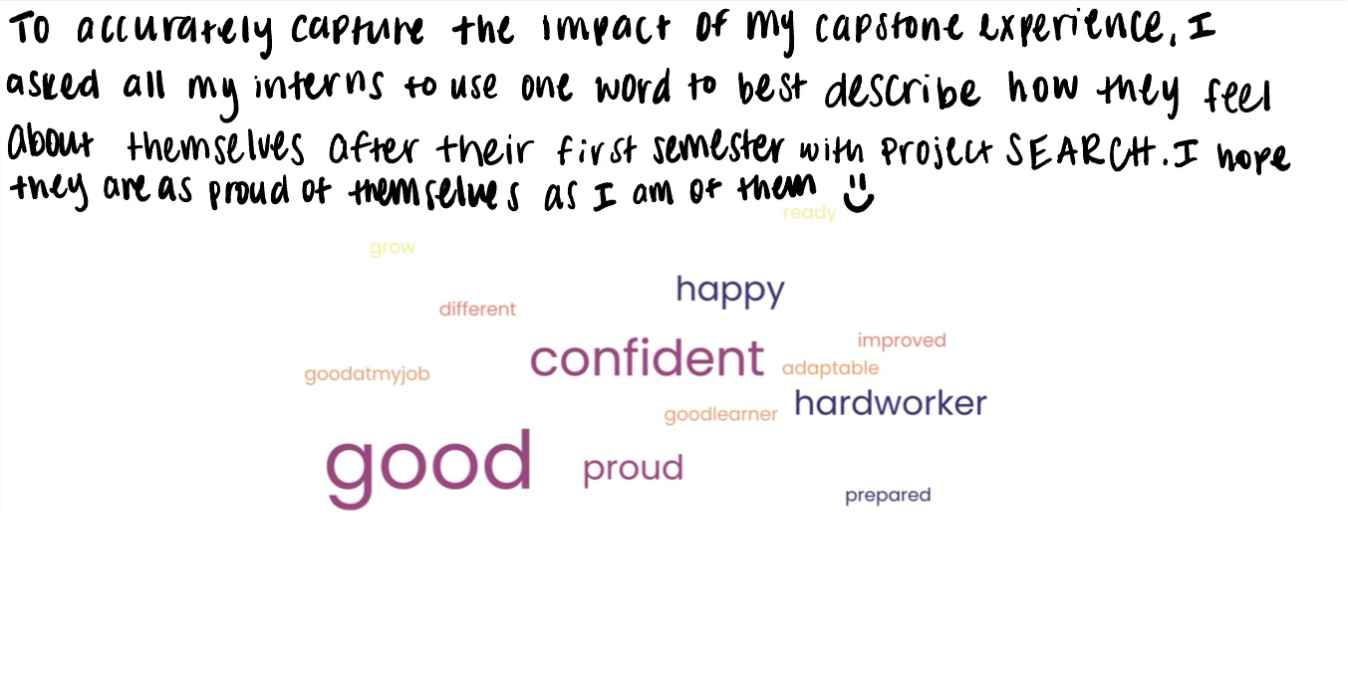

Appendix A: Literature Table
The following Literature Table was produced prior to final capstone plans being finalized. As my project has been modified, so has the literature associated with it.

APA Reference |  | Research Design/Level of Research | Participants  (who and how many) | Type of data collected  Interviews? Administered a test? Ordinal data  Use this to replicate  Statistical analysis | Tools/Instruments  (COPM, Qol, Semi-structured interview) | Results | Limitations | Comments  (E.g Recomendations)
Roan, C., Mailloux, Z., Carroll, A.,, Schaaf; R., (2022) A Parent Guidebook for Occupational Therapy Using Ayres Sensory Integration®. Am J Occup Ther, Vol. 76(5), 7605345020. doi: https://doi.org/10.5014/ajot.2022.049419 | Cross sectional survey |  | Experts in ASI, occupational therapy practitioners who use this approach, and parents of children with autism who received occupational therapy using this intervention | Surveys were designed to obtain feedback about the content, acceptability, and usefulness of the parent guidebook. | Cross sectional survey, likert scales, qualtrecs, | Experts rated the guidebook as consistent with ASI principles, practitioners rated it as clinically useful, and parents rated it as useful and clear. | Only 8 people total reviewed the book, in the future a larger sample size would create more diverse results | This article emphasizes the importance of parent knowledge when it comes to sensory integration as well as how easy/accessible that information is
Larson K. S., Nielsen, S., Hemberger, K., Klug, M. G.; (2021) Addressing Puberty Challenges for Adolescents With Autism Spectrum Disorder: A Survey of Occupational Therapy Practice Trends. Am J Occup Ther , Vol. 75(3), 7503180020. doi: https://doi.org/10.5014/ajot.2021.040105 |  | A nonexperimental survey design with a stratified random sample was used | Occupational therapists (89%) or occupational therapy assistants with experience with adolescents who have ASD were included. The 71 eligible respondents were primarily White women with an average 16 yr of experience. | qualtrecs |  | Puberty comes with many factors that may effect occupational performance and are an imperative part of education to the child | lacks phsychometric  Rigor  - lack of diversity, limited number of participants, and a large portion of respondents being from North Dakota and Minnesota  -study didn’t investigate if lack of knowledge was being addressed by another discipline | This article is important because it addresses a key part in development in kids that all parents will have to have discussions about at some point. This article talks about the importance in doing so as well as ways to do it. I think this is important for my capstone because it can be a topic of conversation within my education program
Miller-Kuhaneck, H., &, Watling, R.; (2018) Parental or Teacher Education and Coaching to Support Function and Participation of Children and Youth With Sensory Processing and Sensory Integration Challenges: A Systematic Review. Am J Occup Ther , Vol. 72(1), 7201190030p1–7201190030p11. doi: https://doi.org/10.5014/ajot.2018.029017 |  | Systematic review  Level 1 and level 2 studies | Documented defecit in SI or SP |  | Systematic review | All articles reported improvement in child functions and parents confidence and quality of life | Only 4/11,600 articles met  Varied outcomes measured  potential bias due to parent report  articles didn’t typically involve OT results | Generally, the literature has supported the use of parent training and parent-mediated interventions for altering child behavior, and some evidence has shown that parent training programs can also improve parent stress, well-being, mental health, and self-efficacy as well as parent–child interaction
Bendixen, R. M., Elder, J. H., Donaldson, S., Kairalla, J. A., Valcante, G., & Ferdig, R. E. (2011). Effects of a father-based in- home intervention on perceived stress and family dynamics in parents of children with autism. American Journal of Occupational Therapy, 65, 679–687. doi: 10.5014/ajot.2011.001271 |  | Quasi-expirimental | Recruited from university of FL sutism center  Had to have an autism diagnosis  19 children and their parents |  | SAS version 9  Paired T test  Perceived maternal and paternal stress scales  Interviews  ADR semi structured pre/post interviews | Patermal PSI score eedecreased  Maternal psi score decreased | Limited research on the topic | Due to the results of PSI scores decreasing for both mothers and fathers the study concluded that father based in home intervention was useful
Trewin, A., Mailloux, Z., & Schaaf, R. C. (2022). Brief Report—Evaluation of MealSense©: A sensory integration–based feeding support program for parents. American Journal of Occupational Therapy, 76, 7603345020. https://doi.org/10.5014/ajot.2022.046987 |  | Descriptive study | : A convenience sample of expert reviewers (n 5 5) and parents of children with ASD and feeding challenges (n 5 5). | This study was determined by the Thomas Jefferson Institutional Review Board to be exempt from review | In this descriptive study, we distributed electronic sur- veys (Qualtrics) and a MealSense program link to expert reviewers and parents of children with ASD and feeding difficulties to obtain feedback about the program’s content, acceptability, and usefulness. | Expert ratings (n 5 5) met criteria showing that MealSense is consistent with ASI and evidence-based practices in feeding. Parent ratings (n 5 5) met criteria showing that MealSense is acceptable and useful. | Conveinienace samples can be hard to generalize  Small number of participants could have caused bias | There is a need for a parent education program for feeding programs for kids with asd
Rachey, Kalindi and Johnson, Hailey. (2021) Parental Caregiver Guide For An Adolescent With Down Syndrome: Transitioning Out Of High School. Occupational Therapy Capstones. 475. https://commons.und.edu/ot-grad/475 |  | Scoping review on literature regarding parent education programs | No research participants but directed towards parents of adolecents with DS | N/A | Ecology of human performance | N/A- could expand on this by seeing if the guide was actually helpful or not | N/A | Recommendations for further development of this manual in the future include research and developing a class based on the contents of the manual. Future research on the manual, particularly the efficacy and the usefulness of the manual and, in turn, making the associated changes to improve the effectiveness of the manual and its contents for its consumers
Vitosh, Delanie, "Educating the Interprofessional Team and Family About Sensory Challenges Children with Autism Spectrum Disorder May Experience" (2022). Occupational Therapy Capstones. 528. https://commons.und.edu/ot-grad/528 |  | An extensive literature review was conducted to acquire information to create evidence-based strategies for the interprofessional team and families to use | N/A- geared towards intraprofessional team members and family members | N/A | Ecology of human performance | N/A could be expanded on bby testing whether or not the program worked | N/A | It is anticipated that the sensory education program will help to educate the parents and the interprofessional team on a variety of sensory approaches that could be used outside of the occupational therapy environment to facilitate participation in daily routines and occupations.
Soulek, Audrey Lind, "A Home-Based Program To Support Parents/Caregivers Of Children With Complex Developmental Needs In Their Home Environment" (2022). Occupational Therapy Capstones. 532. https://commons.und.edu/ot-grad/532 |  | Synthesis of evidence-based literature  Literature review | N/A- parents and caregivers as well as early intervention specialists | N/A | MOHO | N/A- no results due to the fact it was a scoping review. But all literature points to the importance of having a good relationship between early intervention specialists and parents and how important proper coaching of the parents is | N/A | it can be concluded that EI providers and parent/caregiver relationships are essential to ensuring a collaborative and client-centered process
Jamali, A. R., Alizadeh Zarei, M., Sanjari, M. A., AkbarFahimi, M., & Saneii, S. H. (2022). Randomized controlled trial of occupation performance coaching for families of children with autism spectrum disorder by means of telerehabilitation. British Journal of Occupational Therapy, 85(5), 308–315. https://doi-org.xavier.idm.oclc.org/10.1177/03080226211061492 |  | Pre trial/post trial | 43 children with autism and their families  4-12 years old  Recruited from an Iranian autism association | Goal attainment  Parent efficacy | COPM  Matched-pairs waitlist rct | Significant improvement in children’s performance was reported in this study. | Lack of control group  High education level of parents  Was not possible to implement a double blind approach | Through occupational performance coaching  It was discovered that children with ASDs behavior improved
Alexander, K., Kenworthy, L., Laura Anthony, Childress. D., Verbalis, A., Armour, A., Kocher, K., Troxel, M., Cannon, L., Werner, M.; Leveraging Technology To Develop a Feasible, Acceptable, and Effective Alternative to In-Person Parent Education Sessions. Am J Occup Ther August 2019, Vol. 73(4_Supplement_1), 7311520397p1. doi: https://doi.org/10.5014/ajot.2019.73S1-PO2038 |  | We randomly assigned 85 parents of children on the autism spectrum (mean age= 10.3 years; mean IQ= 104) to participate in e-Unstuck (n=41) or two in-person education sessions (n=44) | 85 parents of children with ASD | Outcome measures were all parent-rated, including: self-ratings of sense of parenting strain, empowerment, and competence in addition to ratings of their child’s EF difficulties and their contribution to challenges in daily life. | Parent rated, self rated report | Significant improvement in all parent selfratings, as well as parent ratings of their child’s executive function difficulties |  | e-Unstuck is an effective, feasible, and acceptable alternative to in-person parent education sessions  parent  education  programs  aree effective  and improve  QOL for p  Parents  And kids
Allen, S., Knott, F.J., Branson, A., & Lane, S. J. (2021) Coaching parents of children with sensory integration difficulties: A scoping review. Occupational Therapy International, 2021. https://doi.org/10.1155/2021/6662724 |  | Scoping review.  Level of evidence was identified using Oxford Center for Evidence-Based Medicine Levels of Evidence. | Inclusion criteria stated articles must be written before January 2020, peer reviewed, English speaking, empirical papers.  4 studies met inclusion criteria | Improved outcomes were observed in child functional skills and behavior as well as parent sense of competence and reduced parent stress. | Preferred Reporting Items for Systematic Reviews and Meta-Analyses. | a coaching or problem-solving approach to support parents in developing skills to better manage their children, all of whom had autistic spectrum disorders and sensory integration challenges that caused disruption to daily activities. | Limited transferability of results in available. | It is possible to educate parents on sensory integrarion and sensory processing and have them translate it to everyday life
Ashburner, J.K., Rodger, S. A., Ziviani, J.M, & Hinder, E.A. (2014).Optimizing participation of children with autism spectrum disorder experiencing sensory challenges: a clinical reasoning framework, Canadian Journal of Occupational Therapy, vol. 81, no. 1, pp. 29–38. https://doi.org/10.1177/0008417413520440 |  | Clinical reasoning framework | Studies involving participants with ASD reported in peer-reviewed journals written in English published from 1990 to May 2013 were sourced | Data comes from searching through literature based on interventions administered | Autism disagnostic interview, | the proposed clinical reasoning framework recommends starting with an information-sharing and coaching approach that enables families to develop their own solutions. | Methodoligical limitations were seen in individual studies but were not stated specifically | This article talks about different OT approaches to sensory chalnneges and the outcomes of each approach
Bagby, M. S., Dickie, V. A., & Baranek, G. T. (2012). How sensory experiences of children with and without autism affect family occupations. American Journal of Occupational Therapy, 66, 78–86. doi: 10.5014/ajot.2012.000604 |  | Grounded theory approach | Parents of typically developing children and of children with autism | Telephone or face to face interviews with parents | Parents’ Evaluation of Developmental Status (Glascoe, 2000), a standardized parent-report measure used to screen for children with developmental concerns | Children’s sensory experiences affected (1) what a family chose to do or not do; (2) how the family prepared; and (3) the extent to which experiences, meaning, and feelings were shared. | Results are less likely to be generalized due to convenience sampling | Chlldrens sensory experiences affect family occupations so having parens with knowledge in that area will be benficial
McKnight, L.M., O’Malley-Keighran, M.-P., Carroll, C, (2016). Just wait then and see what he does: A speech act analysis of healthcare professionals’ interaction coaching with parents of children with autism spectrum disorders. International Journal of Language & Communication Disorders, 51(6), 757-768. 10.1111/1460-6984.12246 |  | Retrospective study | 2 SLPs and 1 OT | Coaching sessions were given and then analyzed based on outcomes | Video recordings of treatment sessions | The study provides an insight into the nature of interaction coaching provided by healthcare professionals during a parent training programme | N/A | Aims to increase awarenwss of how to deliver information during parent education programs
Ono, E., Friedlander, R., & Salih, T. (2019). Falling through the cracks: How service gaps leave children with neurodevelopmental disorders and mental health difficulties without the care they need. BCMJ, 61(3), 114–124 |  | Clinical vignettes- reports of clinical cases  Also inclused a literature review | 4 children with varying neurodevelopmental disabilities and their families | Interviews were done with families to analyze their cases and find the service gaps needing to be addressed | interviews | Gaps were identified in the system in which kids with dual diagnoses seek care | N/A | Families often do not have access to useful materials or resourcces and that negatively impacts the child as well as their family. It usually leads to major mental health concerns
Reynolds S.,Glennon, T.J., Ausderau, K., Bendixen, R.M., Miller-Kuhaneck, H., Pfeiffer, B., Watling, R., Wilkinson, K., Bodison, S.C.; (207) Using a Multifaceted Approach to Working With Children Who Have Differences in Sensory Processing and Integration. Am J Occup Ther , Vol. 71(2), 7102360010p1–7102360010p10. doi: https://doi.org/10.5014/ajot.2017.019281 |  | No research collected- this article is a statement addressing the importance of a multifaceted intervention approach with kids who have sensory processing problems | N/A- not a study | N/A- not a study. Although, facts from previos studies are cited to bahk up claims | N/A | Interventions must be multifaceted, take into account the environment and its adaptability, include caregivers, and be child focused | N/A | Care for children with disabiliteis must change over time as the child changes. It also needs to focus on many different factors and not just one. Parent involvement is also crucial
Schultz, T. R., Stichter, J. P., Herzog, M. J., Mcghee, S. D. and Lierheimeier, K., (2012), Social competence intervention for parents (SCI-P): comparing outcomes for a parent education programme targeting adolescents with ASD. Autism Research and Treatment Volume 2012. doi:10.1155/2012/681465 |  | quasiexperimental | Participants in this study were the parents of children who participated in an after-school social competence intervention program for youth (SCI-A) at a Midwestern interdisciplinary autism center | An intervention program was completed for the children in these families and results were analyzed | Social competence intervention for parents | Parents of youth with ASD are at risk for increased stress levels, social isolation, and disrupted family dynamics Additionally, parents of youth with ASD report difficulty in accessing information related to their child's ASD | Small sample size, not completerly randomized, attendance from parents was sometimes compromised by outside factors | In order to aleveiate feelings expressed in results column, a aprents education program is crucial for parents of children with ASD and will result in the best outcomes
Woo, C. C., & Leon, M. (2013). Environmental enrichment as an effective treatment for autism: A randomized con- trolled trial. Behavioral Neuroscience, 127, 487–497. https:// doi.org/10.1037/a0033010 |  | Randomized control trial | 28 male children diagnosed with autism aged 3-12 | Intervention program was administered | ADOS scores, CARS scores, Leiter-R scores, or Expressive One-Word Picture Vocabulary Test scores  Test of cognitive perfromance | Senosorimotor enrichment is a crucial part of autism intervention and should improve behavior | N/A | Enviromanental enrichment is beneficial in minimizing effects of autism

Appendix B: Scoping Review

Purpose
During my doctoral capstone project, I will be partnering with Project Search (PS) at Xavier University. PS is a program that young adults can enroll in after they have graduated high school but were on the special education track while there. In the program they are given an internship role and assigned jobs on Xavier’s campus. The purpose of PS is to give these individuals a meaningful way to fill their days and to be given the opportunity to contribute to their community at their own level. Along with PS, there is a program called the exceptional student association (ESA) where general education students at Xavier intermingle with the PS interns in an effort to encourage social participation and a sense of belonging for the PS interns.
The end goal of this capstone project is to bridge the gap between the two groups of differing ability level students. The idea is to promote integration and help students from both groups feel comfortable interacting with their peers of any ability level. Throughout this needs assessment, the importance of integration of special education students and general education students will become abundantly clear (Roldan, S. M., et al., 2021).
Literature Review
It is not a new concept that education can change the mindset of a neurotypical person’s opinion on a neurodivergent person (Duque, E., et al., 2020). Many people are not taught what a disability really is or how you should interact with a peer who may have some form of disability. On the other side, children who are placed in special education are given minimal guidance on how to appropriately interact with their neurotypical peers. This lack of education and exposure can be a root cause of why so many people choose to ignore their peers with disabilities due to fear, lack of comfortability, and perceived difference in cognition levels (Rossetti, Z., 2024). This lack of integration can be detrimental to the development of both neurotypical and neurodivergent groups of individuals.
Not only do students with disabilities have the potential to fall behind academically, but they tend to fall behind socially as well. Offering individuals with disabilities the opportunity to interact with their peers presents the opportunity to develop these necessary life skills (Fernandez-Villardon, A., et al., 2020). Although the project search interns are not technically in school anymore, they still may be lacking these skills and have the right to be awarded the opportunity to learn.
A study done in 2017 presented the idea that integrating the two groups of students promoted an overall improvement in general education students’ attitudes towards inclusion. It also showed that the individuals whose minds had been changed regarding inclusion were more likely to spread the word of inclusion to their friends and also develop close friendships with their peers who have disabilities (Grutter, J., et al., 2017). Not only is the goal of this project to encourage inclusion, but it is also to open the eyes and hearts of those who may have no exposure to disability in the past. The purpose of this capstone serves to give education behind these ideas so they can become a reality on Xavier Universities campus.
It is clear there is an abundance of information supporting the benefits of integration of general and special education students, not just for the ones with a disability but for the neurotypical individuals as well. It is also apparent that having education to back those interactions and integration has been proven useful and will be most beneficial in the end product (Alshahrani, B., 2023).

Population analysis
The current number of young adults with some form of developmental or intellectual disability in the United States is roughly 1.3 million (U.S Department of Health & Human Services, n.d.). And according to a study done by the Bascule Disability training institute (2014), around 67% of Americans report discomfort in interacting with those with disabilities. This proves why interventions such as this capstone project are so crucial. The intended target audience of this capstone project is the interns of project search, and the students who are members of the ESA. Upon observation of both groups as well as conversation with the head of PS, Angie, it is evident that guidance on interaction is beneficial. Interacting with your peers who have disabilities does not come naturally to everyone and can be a challenge. The ESA students are not incompetent, but, with more education and information, they can become better equipped to interact with those with disabilities and ultimately improve the partnership between ESA and PS.
Along with the ESA students receiving this education, the PS interns will also be given education on how to appropriately interact with their peers. Since the PS interns are no longer in school, they have limited interaction with people their age. They also may not have had the opportunity to appropriately interact with peers in their younger years or been given proper education on how to do so. Individuals with disabilities often have trouble with initiation of conversation, finding a common interest, and deciphering what is appropriate in conversation and what is not (Agaronnik, N., 2019). A component of the end goal of this project is to improve the individuals with disabilities confidence and capability of interacting with their neurotypical peers.
Site Interviews
An interview was conducted with Angie the project search director via Zoom. Throughout the interview, topics of what the capstone project would entail, how the information would be disseminated, and plans for future events and meetings were discussed. Angie and I agreed on many aspects of the plan and together decided what would be most beneficial for our partnership. Her main request of “bridging the gap between general education students and special education students” is where the primary goal of this project stems from.

Justification
As the research shows, integration of special education students and general education students is imperative for growth and development, social participation, and overall happiness of all who are involved. There is a clear need for guidance directed toward both neurodiverse and neurotypical individuals on how to improve their interaction and inclusion, but, the goal of this project is to accomplish just that. This doctoral capstone will serve as a steppingstone to other projects similar to this to continue to strive for inclusion of all students.

References

Agaronnik, N., Campbell, E. G., Ressalam, J., & Iezzoni, L. I. (2019). Communicating with Patients with Disability: Perspectives of Practicing Physicians. Journal of general internal medicine, 34(7), 1139–1145. https://doi.org/10.1007/s11606-019-04911-0

Alshahrani, B. (2023). Interaction Between Students With and Without Disabilities in an Inclusive School from Their Teachers’ Perspective. Journal of Science Education. DOI: 10.14448/jsesd.13.0007

Bascule Disability Training. (2014). Why are we awkward around people with disabilities? https://bascule.com/why-are-we-awkward-around-people-with-disabilities/#:~:text=If%20you%20are%20familiar%20with,to%20a%20person%20with%20disabilities.

Duque, E., Gairal, R., Molina, S., & Roca, E. (2020). How the Psychology of Education Contributes to Research With a Social Impact on the Education of Students With Special Needs: The Case of Successful Educational Actions. Frontiers in psychology, 11, 439. https://doi.org/10.3389/fpsyg.2020.00439

Fernandez-Villardon, A.; Alvarez, P.; Ugalde, L.; Tellado, I. (2020). Fostering the Social Development of Children with Special Educational Needs or Disabilities (SEND) through Dialogue and Interaction: A Literature Review. Social Sciences., 9, 97. https://doi.org/10.3390/socsci9060097

Grutter, J., Gasser, L., & Malti, T. (2017). The role of cross-group friendship and emotions in adolescents attitudes towards inclusion. Research in Developmental Disabilities. Pg 137-147. https://doi.org/10.1016/j.ridd.2017.01.004

Molina Roldán, S., Marauri, J., Aubert, A., & Flecha, R. (2021). How Inclusive Interactive Learning Environments Benefit Students Without Special Needs. Frontiers in psychology, 12, 661427. https://doi.org/10.3389/fpsyg.2021.661427

Office of Population Affairs. (n.d.). Trends in Prevalence of Disabilities Among Youth. U.S Department of Health & Human Services. https://opa.hhs.gov/adolescent-health/physical-health-developing-adolescents/introduction-chronic-conditions/trends-disabilities-youth

Rossetti, Z. (2024). Not Sure How to Approach Them the Right Way: Nondisabled Students’ Perspectives on Friendship With Peers With I/DD. Remedial and Special Education, 0(0). https://doi-org.xavier.idm.oclc.org/10.1177/07419325231221215

Appendix C: IRB Application

Attached to canvas submission

Appendix E: Capstone Goals and Objectives for a Capstone Project Table and a Capstone Experience Table

Goal# | Project Goal | Activities | Proposed Timeline for Meeting Goal | Proposed Evidence of Achievement
1 | I will create a semi-structured interview to determine the most useful skills to be taught to project search interns | 1. Write interview questions and review with Leah and Angie  2. Practice and review interviewing techniques | Interview questions will be finalized by the second week of capstone | 1. Interview questions approved by Leah  2. Practicing interviews with a peer
2 | Angie (head of project search) will demonstrate satisfaction with the unity of the two groups | 1. Participate in biweekly check ins  2. Have an exit meeting to discuss my program and the implementation | 1. Biweekly through the project  2. 11/17/25 (?) | Angie will have minimal complaints of implementation and will continue to use this project from years to come
3 | ESA and project students will report and demonstrate increased comfortability in socializing with each other by the end of the project | 1. Monthly check ins with students to discuss progress  2. Exit interview/discussion to reflect on the project as a whole | 1. Once a month throughout project  2. 11/3/25 (?) | Students report feeling better prepared to socialize with their peers of differing abilities

Goal# | Learning Goal | Activities to Achieve Goal | Proposed Timeline for Meeting Goal | Proposed Evidence of achieving Learning Goal
1 | Practice: Demonstrate effective communication skills and work interprofessionally with those who receive and provide care/services. | 1. Conduct interviews with ESA members, Angie, and Xavier staff identify skills needed for interns and ESA students to succeed  2. Leading weekly life skill and socialization groups | 1. 9/1/25  2. 9/22/25-10/27/25 | 1. Interview data is collected  2. Students complete an exit ticket
2 | Ethics: Display positive interpersonal skills and insight into one’s professional behaviors to accurately appraise one’s professional disposition strengths and areas for improvement. | 1. Hold biweekly check ins  2. Complete weekly self-reflection | weekly/biweekly | 1. Signed timesheet containing progress  2. Weekly Journal entries in capstone journal
3 | Advocacy: Exhibit the ability to practice educative roles for consumers, peers, students, interprofessionals and others. | 1. Conduct weekly life skills and social skills groups for project search interns and ESA students  2. I will be sure to advocate for my students and fix any problems they may have | Weeks 6-11 | 1. Elements of OT to be involved will be fact checked by Leah as evidenced by signed idea sheet  2. Problems brought to me are resolved through a meeting and resolution until problem is solved
4 | Leadership: Develop essential knowledge and skills to contribute to the advancement of occupational therapy through scholarly activities. | 1. leader of the weekly skill groups  2. I will hold weekly check ins with students from both groups to ensure comfortability, build rapport, and allow space for questions or concerns through physical “check-in” handouts | From 9/22/25-10/27/25 | 1. Interventions will be carried out every week and documented on progress time sheet  2. Students report progress as evidenced by an increase on progress report sheet (to be fabricated after interviews)
5 | Scholarship: Apply a critical foundation of evidence based professional knowledge, skills, and attitudes. | 1. Conduct qualitative data analysis of Project Search and ESA student interviews  2. Groups will incorporate topics and interventions supported by literature | 1. 9/8/25-9/15/25  2. 9/8/25-9/15/25 | 1. Students report progress as evidenced by an increase on progress report sheet (to be fabricated after interviews)  2. articles are cited and used in presentations
6 | Individual Student Learning Goal  Present capstone results in a scholarly manner verbally and in writing | 1. create a 3-5 minute video summarizing capstone project  2. prepare a 15 minute summary of the capstone project at the capstone symposium which will include graphics summarizing data and outcomes | 12/1/25 | 1. Capstone video on OTD repository  2. Capstone symposium PowerPoint
7 | Individual Student Learning Goal  Exhibit the ability to create and implement an effective and sustainable skills training program | 1. Create ~10 skills group session/activities to be used by project search in the future  2. Exit ticket showing improvement of the two groups | 11/3/25 | 1. Skills groups are successful and reused in the future  2. Exit tickets are complete and show progress

Appendix F: Signed Memorandum of Understanding

Capstone Student Name  Maddie Bloemer | Capstone Site Mentor Name  Angie Watson
Email Address  bloemerm@xavier.edu | Title/Position
Phone Number  859-496-7078 | Email Address  watsona@greatoaks.edu
Address  11072 Galileo blvd, Union, KY 41091 | Phone Number
Site Information
Name  Project Search at Xavier University | Alternate Contact Name/ Position
Phone Number  513-745-3000 | Phone Number
Address  3800 Victory Parkway | Email Address

Memorandum of Understanding (MOU), effective August 2025 by and between above named doctoral student, Capstone Site, Capstone Site Mentor, and the Department of Occupational Therapy at Xavier University. The following lists the individualized Learning Objectives for Maddie Bloemer, the Mentoring Plan, and the Responsibilities of all Parties involved.
Learning Objectives
XU Doctoral Capstone Learning Objectives
1. Practice: Demonstrate effective communication skills and work interprofessionally with those who receive and provide care/services.
2. Ethics: Display positive interpersonal skills and insight into one’s professional behaviors to accurately appraise one’s professional disposition strengths and areas for improvement.
3. Advocacy: Exhibit the ability to practice educative roles for consumers, peers, students, interprofessionals and others.
4. Leadership: Develop essential knowledge and skills to contribute to the advancement of occupational therapy through scholarly activities.
5. Scholarship: Apply a critical foundation of evidence based professional knowledge, skills, and attitudes.
Individualized Student-Centered Learning Objectives
- At the end of the fall 2025 semester, I will present my capstone results in a scholarly manner verbally and in writing at the Xavier University capstone symposium.
- At the end of the fall 2025 semester, I will exhibit the ability to create and implement an effective and sustainable skills training program to help unify two groups of students.
Project Outcomes
1. I will create a semi structured interview to determine the most useful skills to be taught to project search interns and exceptional student association members
2. The director of project search will demonstrate satisfaction with the unity of the two groups
3. ESA and project students will report and demonstrate increased comfortability in socializing with each other by the end of the project
Plans for Mentoring
Capstone student and Site Mentor plan to meet in capstone mentors’ office and/or via Microsoft Teams, biweekly. Student will maintain a detailed record of all mentoring meetings.
Responsibilities of All Parties
Student is Responsible for:
- Working collaboratively with the Doctoral Capstone Coordinator, Site, and Faculty Mentor to create specific learning objectives for the doctoral capstone experience.
- Working collaboratively with the Doctoral Capstone Coordinator, Site, and Faculty Mentor to create specific project outcomes for the doctoral capstone project.
- Adhering to all policies and procedures of the facility unless exempted, including prompt notification of student absences.
- Fulfilling all duties and assignments as specified by the Capstone Site Mentor, unless exempted, within the time limit specified.
- Completing 14 weeks of full-time doctoral experience. Absences must be made up to ensure 14 weeks of full-time doctoral experience.
- Evaluating the Capstone Site Mentor and Capstone Site to help continue to improve educational outcomes.
- Writing a letter of appreciation to the Site Supervisor and the Capstone Site Mentor for the educational opportunities offered to the student.
- Comply with all policies, procedures, and requirements in the Xavier University Occupational Therapy Doctoral Capstone Manual.
Capstone Faculty Mentor is Responsible for:
- Advising the student on possible practice settings for the doctoral experience.
- Mentoring the student in reviewing evidence, assessments, and interventions relevant to the selected doctoral experience area.
- Making periodic contact with the student.
Capstone Coordinator is Responsible for:
- Ensure that a signed MOU is in place for the capstone site, focusing on a student’s topic of interest.
- Mentoring and orienting students to the general purposes of the doctoral experience and project and providing them with needed forms.
- Making periodic contact with the student as needed.
- If necessary, develop and implement a policy for withdrawing students from a doctoral experience.
- Reassigning students who are not successful in the doctoral experience in accordance with policies and procedures in the Xavier University Occupational Therapy Doctoral Capstone Manual.
Capstone Site Mentor is Responsible for:
- Collaborating with the student and Doctoral Capstone Coordinator in the development of the doctoral experience learning objectives that provide opportunities for the practical implementation of theoretical concepts offered previously during the Occupational Therapy Doctoral program at Xavier University.
- Evaluating each student at the midpoint and conclusion of the doctoral experience using the Learning Objectives and Project Outcomes listed above. The Site Mentor will be provided with the evaluation form.
- Collaborating with the student, Xavier University Capstone Coordinator, and Institution to ensure success and address concerns as they arise.
- Being familiar with the policy regarding the "withdrawal of students from doctoral experience" for Xavier University.
- Providing student mentoring meetings as outlined and additional as indicated.
Ownership of Work Product
Materials developed for the site (i.e. handouts, program protocols) by the student are exclusively the property of the site.
OR

Materials for developed for the site (i.e. handouts, program protocols) by the student are co-owned by the capstone student and Capstone Site and therefore can be used by both parties in the future without additional consent.
Authorship
Authorship Not Applicable
Memorandum of Understanding Addendum A

By signing the agreement, all parties agree to the provisions above.

Maddie Bloemer 12-12-24
Student Date

Doctoral Capstone Coordinator Date

Capstone Faculty Mentor Date
12/10/24
Capstone Site Date

Appendix G: IRB Letter of Response
November 3, 2025
Madeline Bloemer
Xavier University
Dear Ms. Bloemer: The IRB has completed the review of your protocol #25-043, Shared Spaces, Shared Understanding: An Evaluation of a Mentoring Program to Strengthen Relational Quality Between Neurodivergent and Neurotypical Peers using expedited review procedures. We appreciate your thorough treatment of the issues raised and your timely response. Your research activities present no more than minimal risk and involve procedures in categories 6 and 7 of the list of research activities that may be reviewed using Expedited procedures authorized by 45 CFR 46.110. Approval expires November 2, 2026. A progress report, available on our website, is due by that date. If the IRB has not received a progress report from you before MIDNIGHT on the study’s expiration date, we will AUTOMATICALLY set your study’s status to “Closed”. No further data collection is allowed at that point, and if you wish to re-commence data collection, you will be required to submit a new application, along with all relevant materials, to our office. It is your responsibility as the researcher to ensure that your progress report and any request for an extension of data collection is submitted to our office before your approval expires. Any proposed changes to the protocol must be reviewed by the IRB before implementation, unless the change is specifically necessary to eliminate immediate threats to participants’ health and/or wellbeing. You are responsible for adhering to the policies and guidelines set forth by Xavier University’s IRB, which include but are not limited to maintaining proper documentation of study records and promptly reporting to the IRB any adverse events. If you have any questions, please contact the IRB office at 745-2870. We wish you success with your research!

Sincerely,
Morrie Mullins, PhD. Morrie Mullins, PhD.
Interim Chair, Institutional Review Board Xavier University

Appendix H: Week-by-Week Project Plan

Attached to canvas submission

Appendix I: Emotional Regulation Lesson Example

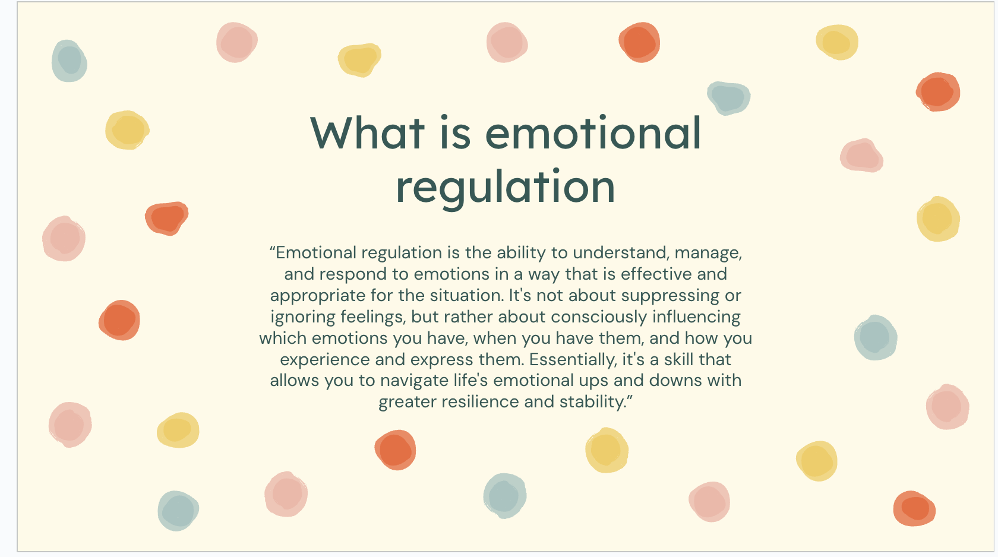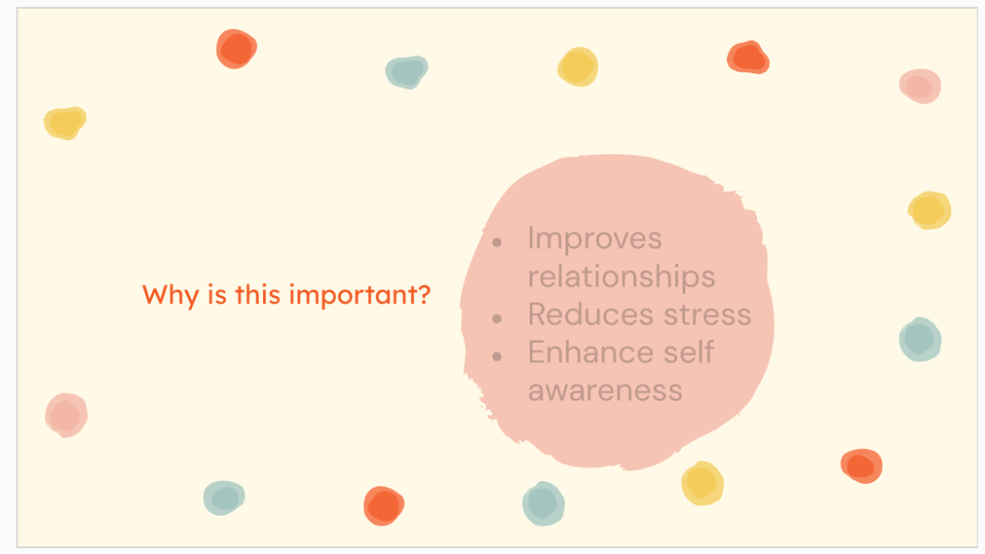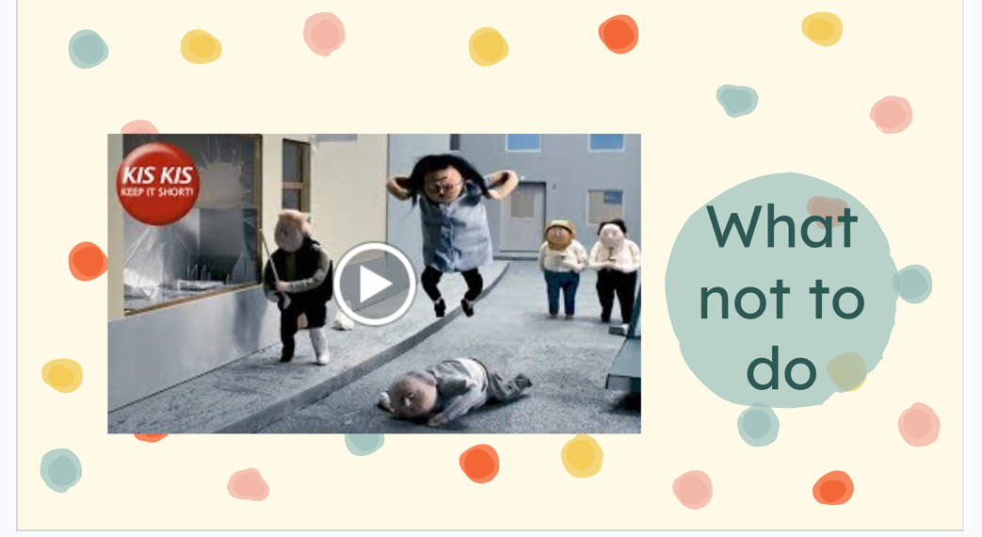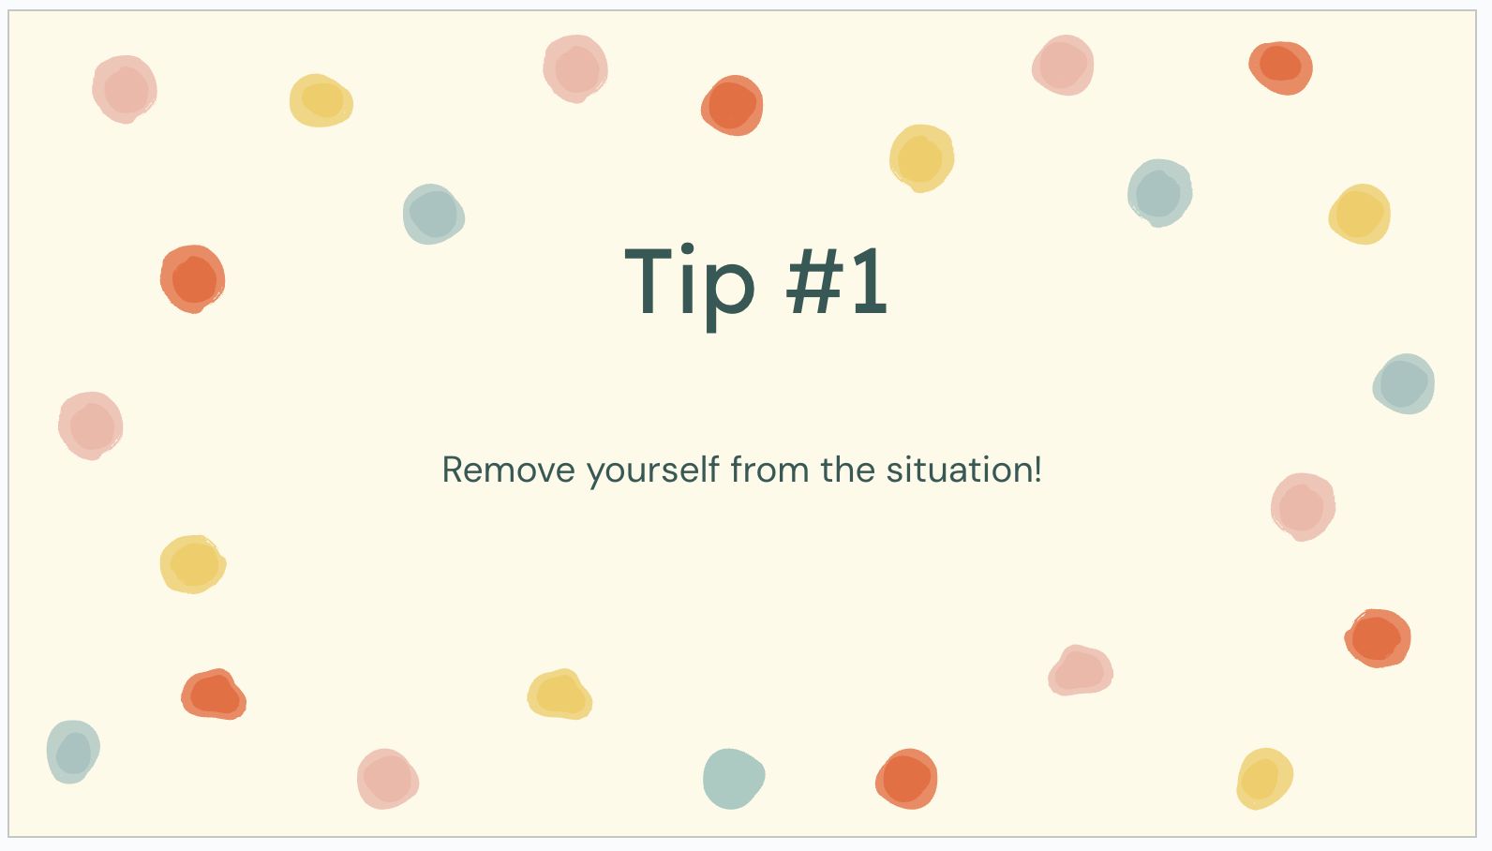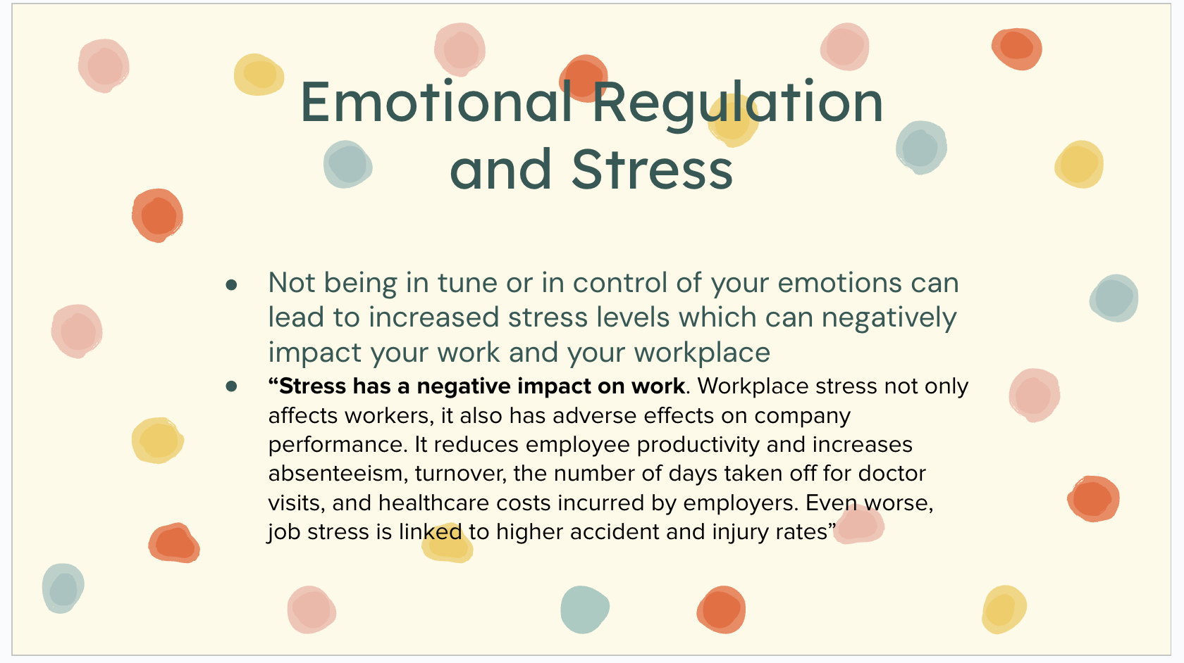

Appendix J: “Tip Tuesday!” Examples

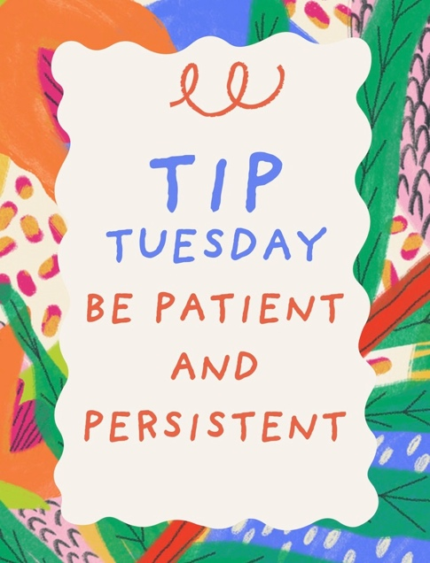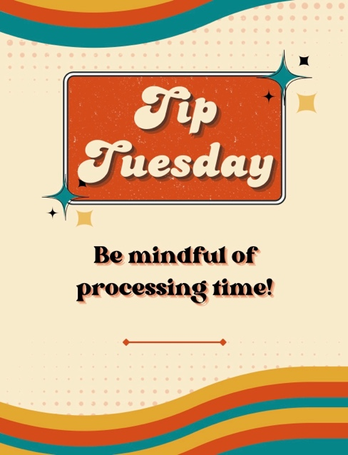

References
Audet, É., Dubois, P., Levine, S., & Koestner, R. (2023). Autonomy support for the academic goal pursuit and subjective well-being of students with disabilities. Cogent mental health, 2(1), 2255040. https://doi.org/10.1080/28324765.2023.2255040
Bascule Disability Training. (n.d.). Why are we awkward around people with disabilities? https://bascule.com/why-are-we-awkward-around-people-with-disabilities/
Dreyfus, S., Honner, K., & Burns, S. (2025). Factors supporting the multifunctional communication of two nonverbal adults with severe intellectual disability. International Journal of Developmental Disabilities, 1–14. https://doi-org.xavier.idm.oclc.org/10.1080/20473869.2025.2539243
Freeman, J. L., Caldwell, P. H. Y., & Scott, K. M. (2025). Adolescents’ trust in health information in an evolving social media landscape. Academic Pediatrics, 25(7), 102868. https://doi.org/10.1016/j.acap.2025.102868
Greaves, N. (2024). Emotion regulation difficulties and differences in autism including demand‐avoidant presentations—a clinical review of research and models, and a proposed conceptual formulation: Neural‐preferencing locus of Control (NP‐LoC). JCPP Advances, 5(2). https://doi.org/10.1002/jcv2.12270
Hornby, G., & Kauffman, J. M. (2024). Inclusive Education, Intellectual Disabilities and the Demise of Full Inclusion. Journal of Intelligence, 12(2), 20. https://doi.org/10.3390/jintelligence12020020
Malka, M., & Rahat‐Drihem, N. (2025). ‘He can be whatever he wants to be!?’: How parents of a child with a disability navigate their expectations for their child’s achievement and success. Child &amp; Family Social Work. https://doi.org/10.1111/cfs.70025
Novak, K. (2024, July 1). Is there evidence that inclusion is actually good for all learners?. Novak Education - UDL, MTSS, and Inclusive Practices PD for Educators. https://www.novakeducation.com/blog/is-there-evidence-that-inclusion-is-actually-good-for-all-learners
Rajotte, E., Grandisson, M., Couture, M. M., Desmarais, C., Chrétien-Vincent, M., Godin, J., & Thomas, N. (2025). A Neuroinclusive School Model: Focus on the School, Not on the Child. Journal of Occupational Therapy, Schools, & Early Intervention, 18(2), 281–299. https://doi-org.xavier.idm.oclc.org/10.1080/19411243.2024.2341643
Saran, A., Hunt, X., White, H., & Kuper, H. (2023). Effectiveness of interventions for improving social inclusion outcomes for people with disabilities in low- and middle-income countries: A systematic review. Campbell systematic reviews, 19(1), e1316. https://doi.org/10.1002/cl2.1316

